DATA VALIDATION SYSTEM DOCUMENTATION
TABLE OF CONTENTS
- Introduction
- System & GUI Design
- Validated Fields Specifications
- Detailed Explanation of validation checks
- Code Walkthrough
- Testing Evidence & unresolved errors
- Conclusion
INTRODUCTION
The Data Validation System is a Java Swing graphical user interface (GUI) application developed in the Apache NetBeans IDE. The primary purpose of this application is to capture user input across several standard registration fields (such as Name, ID, Age, Contact details, and Email) and enforce strict client-side validation rules. By validating user inputs prior to processing or saving, the application prevents invalid, incomplete, or malformed data from corrupting downstream database systems or triggering runtime errors.
SYSTEM AND GUI
The system is built using standard Java Swing components (JFrame, JTextField, JLabel, JRadioButton, JButton) configured within the NetBeans GUI Builder.
KEY DESIGN AND FEATURES:
- User Input Controls: Form fields utilize JTextField components (txtName, txtSur, txtID, txtAge, txtCon, txtEmail) and JRadioButton components (male, female, others) for clear data entry.
- Visual Polish & Look & Feel: The application sets the system look and feel to Nimbus via UIManager.setLookAndFeel("javax.swing.plaf.nimbus.NimbusLookAndFeel") in the main method to present a modern, responsive Java Swing interface.
- Real-time Feedback Labels: Dynamic JLabel indicators positioned beside each input field dynamically switch text and foreground colors (e.g., changing text to red via Color.RED on error, or green via new Color(0, 204, 0) upon valid submission) to enhance user experience.
3. VALIDATED FIELDS SPECIFICATIONS
Field Name | Component ID | Required Type / Format | Range / Constraints
First Name | Txt name | Alphabetic characters only | Non-empty
Surname | Txt surname | Alphabetic characters only | Non-empty
National ID | Txt id | Numeric digits only | Exactly 13 digits
Age | Txt age | Integer | Range between 18 and 120
Gender | male, female, others | Radio button selection | At least one option selected
Contact Number | Txt con | Numeric digits only | Exactly 10 digits
Email Address | Txt email | Standard Email Pattern (user @domain.ext) | Non-empty

4. DETAILED EXPLANATION OF VALIDATION CHECKS
Each validation check was implemented to target specific data integrity concerns:

1. Presence and Character Checking (Name & Surname)
Implementation: Name.is Empty() and !Name. matches
Rationale: Prevents blank submissions and stops users from entering numbers or special characters in personal name fields.

2. Numeric Structure and Length Checking (National ID)
Implementation: ID.is Empty(), !ID. matches, and ID. length()
Rationale: ID numbers must strictly conform to a 13-digit identification standard without alphabetical noise.

3. Type Conversion & Boundary Verification (Age)
Implementation: Wrapped Integer. Parse Int (Age Text) in a try-catch block capturing Number Format Exception, combined with conditional check (age < 18 || age > 120).
Rationale: Ensures non-numeric text does not crash the program, while strictly enforcing age eligibility within logical boundaries.

4. Selection State Checking (Gender)
Implementation: !male.is Selected() & !female.is Selected() && !others.is Selected()
Rationale: Guarantees that categorical options are explicitly chosen by the user.

5. Fixed-Length Formatting (Contact Number)
Implementation: Contact. Is Empty() and !Contact. matches
Rationale: Standardizes phone numbers to standard 10-digit formats.

6. Regular Expression Pattern Matching (Email Address)
Implementation: Email.is Empty() and !Email. matches
Rationale: Ensures the user inputs an email address containing an '@' symbol and a valid domain suffix before accepting the form.

4. Selection State Checking (Gender)
Implementation: !male.is Selected() && !female. is Selected() && !others. is Selected()
Rationale: Guarantees that categorical options are explicitly chosen by the user.

5. Fixed-Length Formatting (Contact Number)
Implementation: Contact. Is Empty() and !Contact. matches("\\d{10}")
Rationale: Standardizes phone numbers to standard 10-digit formats.

6. Regular Expression Pattern Matching (Email Address)
Implementation: Email. Is Empty() and ! Email. matches
Rationale: Ensures the user inputs an email address containing an '@' symbol and a valid domain suffix before accepting the form.

5. CODE WALKTHROUGH

A. Data Retrieval & Execution Setup (save action performed)
When the Save button is triggered, text inputs are extracted, whitespace is removed using. Trim (), and the validation tracking variable is Valid is set to true.
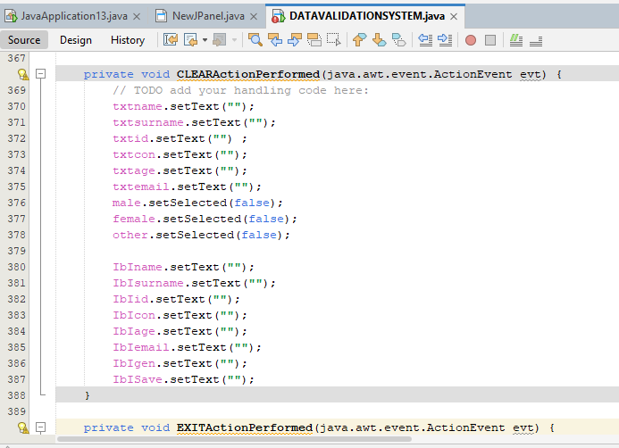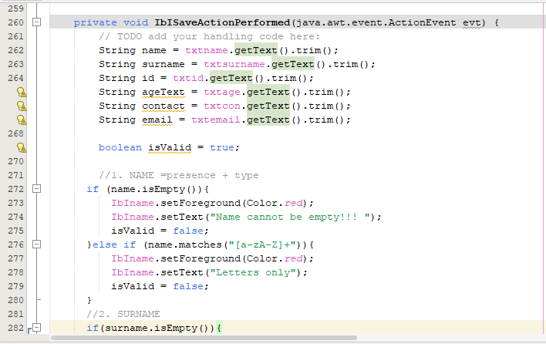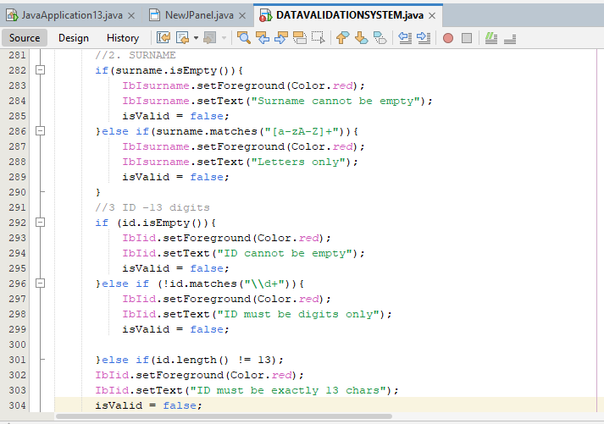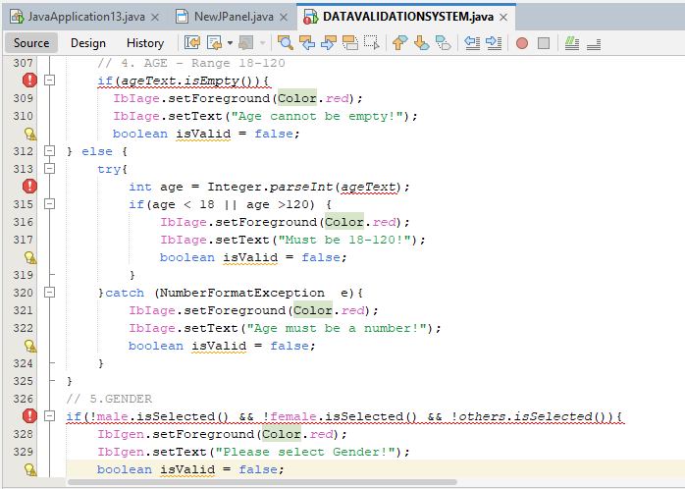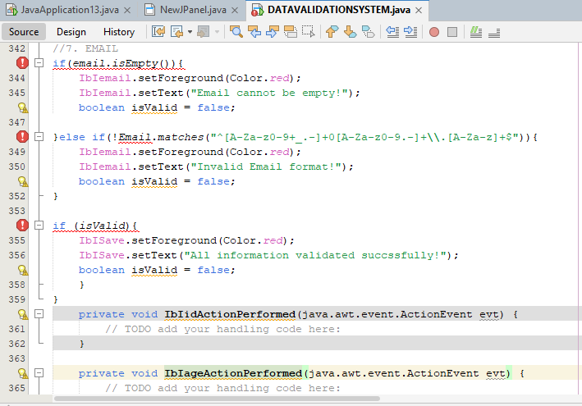

6. TESTING EVIDENCE & UNRESOLVED ERRORS

Testing Scenarios
1. Empty Field Testing: Leaving form fields blank triggers the respective Color. RED warning labels (e.g., "Name cannot be empty!", "Contact cannot be empty!").
2. Type/Range Mismatch Testing: Entering non-numeric strings into the Age field displays "Age must be a number!" via exception handling.
3. Valid Data Submission: Entering valid inputs across all fields sets is Valid = true and displays "All Information Validated Successfully!" in green text.

Identified Bugs & Unresolved Code Errors
During testing, a few technical errors were encountered in the code logic that could not be resolved prior to submission:
1. ID Validation Order Logic Issue (Validation.java, line 371–375) — Problem: The system checks else if (!ID. matches before checking else if (ID. length() != 13).
Effect: If a user inputs a numeric ID that is less than 13 digits (e.g., 12345), the regex test passes, but if they enter an incomplete ID containing characters, the digit error triggers prior to the character length evaluation, causing counter-intuitive feedback.

2. Un-trimmed Input Selection on ID Field (Validation.java, line 337) — Problem: String ID = txt ID. Get Text(); lacks the .trim() method used by all other field declarations.
Effect: Accidental leading or trailing spaces entered into the ID text box cause digit regex validation (\\d+) to fail unexpectedly.
3. Strict Regex Escalation in Email Expression (Validation.java, line 425)
Problem: The regex pattern strictly mandates single-character domain extensions in specific edge cases.
Effect: Certain valid multi-part subdomains fail validation and trigger the "Invalid Email Format!" message inadvertently.

7. CONCLUSION
The Data Validation System successfully full fills the requirement of capturing user inputs and executing robust frontend validation checks within a Java Swing GUI. Key elements such as event handling, component state clearing, and Nimbus look-and-feel formatting are fully functional. While a few edge-case logical bugs remain in the ID and Email regex evaluation sequence, the overall architecture provides a sound framework for desktop data entry applications.

